We now have a webchat feature on our website https://victimfirst.org .You can use our Webchat to speak with a member of Victim First if you have any queries or require any information/advice.
When our Webchat is live and online for you to use, you will see on the website homepage, in the bottom right-hand corner, a large yellow speech bubble with a padlock symbol that says ‘’Chat securely with a team member’’.
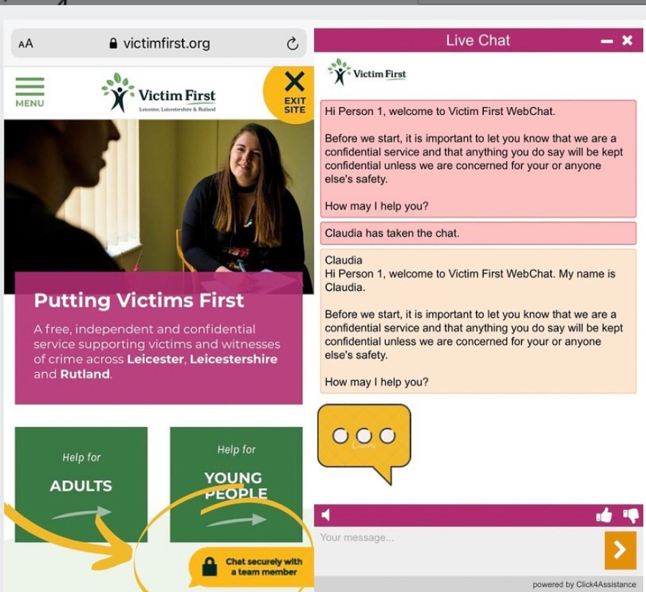
Once you click on the yellow speech bubble, you will be prompted to enter your name and confirm you have read and understood our Privacy Policy.
Once you have done this and clicked ‘start conversation’ your chat will then be picked up by one of our caseworkers, who will do their best to support you with your query.
Please note that the caseworkers may direct you to our Phone line should you need extra support that we aren’t able to provide via the webchat service.

